# Lab 10 Develop the Student Scores application

In this exercise, you will develop an application that tracks student’s scores, tallies the average of the entered scores, and sorts the entered students by last name and score. The interface looks as follows:

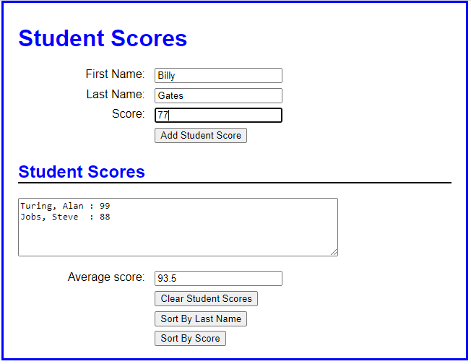

1. Open the HTML and JavaScript files in this folder.
2. In the JavaScript file, note that six functions are supplied.

* $ function,
* displayScores()
* addScore()
* clearScores()
* sortByLastName()
* sortByScore()
* onload event handler that attaches the various functions to the click events of the appropriate buttons and sets the focus on the first name field.

1. An array called names is declared to store Student objects. Each student should be stored in an object as follows:

{ firstName:”Joe”, lastName:”Bloggs”, score: 99 }

There is no need to write methods for this object, just a constructor to create the object.

1. The student data should be stored in localStorage so that it persists between browser sessions. To do this you will have to use the global JSON object to stringify the array before you store it. Use the parse method when reading from localStorage.
2. Follow the comments in the JavaScript file to complete the exercise.